Kol Simcha Torah Gazette
For haazinu and yom kippur 5787
Vol 11 Issue 2 (Whole #513) Tishrei 8 and 10 5787/ September 19&21, 2026
Printed L’illuy nishmas Nechama bas R’ Noach, a”h
For a free subscription, please forward your request to keren18@juno.com
Past emails can be found on the website ShabbosStories.com under Brooklyn Torah Gazette

The Rabbi Who Delayed Kol Nidrei Until Two Jews Made Peace

A remarkable true story of Rabbi Noach Gad Weintraub, who refused to begin the Kol Nidrei service on Yom Kippur until two feuding congregants reconciled, revealing the profound Jewish connection between forgiveness, unity, and atonement
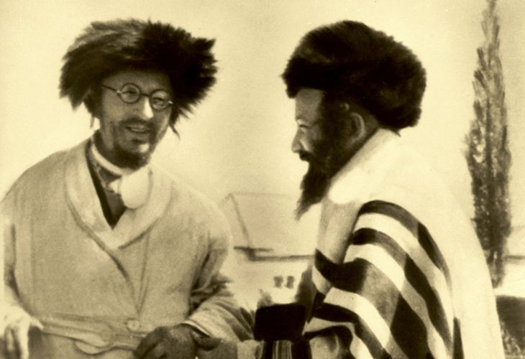
Rabbi Noach Gad, at left, with Rabbi Meir of Amshinov in 5694 (photo: courtesy of the "B'Ohalei Tzaddikim" Institute)

On the seventh of Tishrei, the yahrzeit of the revered Jerusalem sage Rabbi Noach Gad Weintraub of blessed memory is observed. Renowned for his extraordinary mastery of both the revealed and mystical dimensions of Torah, he was regarded in the Chassidic world as one of the greatest transmitters of Torah traditions. His writings preserve teachings and insights he personally heard from more than 500 leading Torah scholars, many of whom he knew closely.
Rabbi Weintraub authored over one hundred books and pamphlets covering every area of Torah scholarship, including profound commentaries on the Five Megillot and Pirkei DeRabbi Eliezer. He was among the foremost disciples of the eminent kabbalist Rabbi Chaim Shaul Dweck HaKohen of blessed memory and, at his teacher's instruction, published Kuntres Tikkun HaYesod.
Nearly a century ago, Rabbi Weintraub immigrated to the Land of Israel from Radomsko, Poland. Long before the destruction of European Jewry, he foresaw the coming catastrophe and remarked that only in the Land of Israel would there be survivors.
One unforgettable story from his years in Tel Aviv has been passed down by residents of the Neve Shalom neighborhood in Jaffa. It is a powerful illustration of his unwavering commitment to peace between Jews.

No Kol Nidrei Without Reconciliation
It was the eve of Yom Kippur. The congregation had gathered for the solemn Kol Nidrei service, dressed in white kittels and filled with awe as they prepared to enter the holiest day of the Jewish year.
Yet beneath the atmosphere of sanctity lay a painful reality. Two members of the synagogue had been locked in a bitter feud for years, casting a shadow over the entire congregation. Rabbi Weintraub had repeatedly tried to help them reconcile, following the example of Aaron the High Priest, who loved peace and pursued peace. Despite all his efforts, both men stubbornly refused to forgive one another.
The service began as expected. The Torah scrolls were removed from the ark, and the synagogue was filled with anticipation. Even those who attended only once a year had come to hear the stirring words of Kol Nidrei.
Then, just moments before the cantor was about to begin, Rabbi Weintraub stepped onto the platform and made an astonishing announcement.
With deep emotion and boundless love for his fellow Jews, he declared that the congregation would not begin the Kol Nidrei service until the two men reconciled.
"If Jews cannot forgive one another," he proclaimed, "and Yom Kippur cannot atone for sins between people until they have made peace with each other, then there is no purpose in praying on Yom Kippur."
His words stunned the congregation. No one dared challenge his decision.
The tension in the synagogue was almost unbearable. Yet despite the gravity of the moment, the two men refused to yield. Their resentment had become so deeply rooted that even the sanctity of Yom Kippur could not immediately overcome it.

A Rabbi Who Would Not Give Up
More than an hour passed in complete silence.
At one point, one of the men appeared ready to give in and make peace, but the other remained unmovable. As the minutes dragged on, the more stubborn of the two finally stood up. Rather than reconcile, he announced that he was leaving the synagogue altogether, insisting that he would never make peace with his adversary.
Many assumed that the matter was over and that the delayed Kol Nidrei service would finally begin.
But Rabbi Weintraub had other plans. Without the slightest concern for his own honor, he hurried after the man, who had already left the synagogue.
"You are free to leave," Rabbi Weintraub told him gently but firmly, "but know this: if you refuse to end this dispute tonight, you will bear the responsibility for preventing an entire congregation of Jews from praying Kol Nidrei."
These heartfelt words, spoken with complete sincerity, pierced the man's heart. The hardness that years of resentment had created suddenly began to melt.
Moments later, to the amazement of everyone watching, the man turned around and walked back into the synagogue alongside Rabbi Weintraub.
He approached his longtime rival. Before the eyes of the entire congregation, the two embraced, wept, and sincerely forgave one another.
Only then did Rabbi Weintraub's face light up with joy.
Those present felt that he had not only broken down the barrier separating two fellow Jews but had also helped remove the spiritual barrier between the Jewish people and their Father in Heaven, allowing the prayers of the holy day to ascend unhindered.
The moment brought to life the verse, "And He became King in Jeshurun, when the heads of the people assembled together." Rashi explains that God is truly King when Israel is united in one fellowship and lives in peace with one another, not when they are divided by conflict.

A Kol Nidrei Like No Other
Late into the night, long after synagogues elsewhere had already completed the Yom Kippur evening service, the congregation in Neve Shalom finally began Kol Nidrei.
Those who were there never forgot it.
"The Kol Nidrei prayer that night," they later recalled, "was filled with such extraordinary repentance, spiritual awakening, and commitment to good deeds that we had never experienced anything like it before."
For Rabbi Noach Gad Weintraub, peace between people was not merely an ideal. It was the very foundation upon which sincere prayer and true atonement could stand.

Reprinted from the website of Hidabroot.com

Why Did Moses Emphasize Heaven and Earth as the Witnesses to the Jews’ Loyalty to the Torah
From the Teachings of the Lubavitcher Rebbe
Rabbi Menachem Mendel Schneerson, Zt”l

This week's Torah portion, Ha'azinu, opens with Moses' words: "Listen, heaven, and I will speak; hear, earth, the words of my mouth." With these words Moses called upon heaven and earth to bear witness concerning his admonitions and exhortations to the Jewish people regarding their performance of Torah and mitzvot (the commandments).
The commentary Sifrei offers an explanation for Moses' selection of heaven and earth as witnesses. "Listen heaven" - because Torah was given from heaven; "hear earth" - because upon it the Jewish people stood when they accepted the Torah and said "All that G-d spoke we shall obey and hear."
Torah and mitzvot were given to us by G-d, Who is infinitely higher than heaven and earth. In seeking to exhort Israel to a greater degree of performance of Torah and mitzvot, it is logical to assume that this could be best accomplished by stressing the fact that Torah and mitzvot were given by G-d, rather than by focusing upon the point that Torah and mitzvot are connected to heaven and earth. Why, then, the emphasis on heaven and earth?
A Jew is expected to serve G-d on two levels: on one hand he is expected to serve G-d with pure and simple faith and with acceptance of the Heavenly Yoke - elements that derive from the soul's essence. On the other hand, his service must permeate his internal powers of intellect and emotions so that they too understand and feel G-dliness.
In practical terms this means that a Jew is to connect his soul's essence with his inner powers, so that not only does he serve G-d in thought, speech, and action out of a sense of simple faith, but he also comprehends G-dliness in his mind and loves and fears Him in his heart.
Moreover, a Jew is expected not only to serve G-d in the general and ongoing manner of regular Torah and mitzvot, he is also to serve Him through repentance - teshuva. This level of service, a level of service that emanates from the soul's essence and seeks the innermost aspect of G-dliness, must permeate the person's powers of intellect and emotion as well.
This is why when Moses desired to rouse the Jews to the service of Torah and mitzvot, whose performance was to be not only with pure faith but with the inner powers of intellect and emotion as well, he mentioned that Torah and mitzvot were given through heaven and earth.
Thus, he aroused within the Jewish nation their inner "heaven and earth," and the lesser powers of emotion, speech and action that are likened to and on the level of earth.

Reprinted from the 2003/5764 Parashat Ha’azinu edition of L’Chaim, a weekly publication of the Lubavitch Youth Organization.

Rav Avigdor Miller on
Justifying Misfortune – Part 1

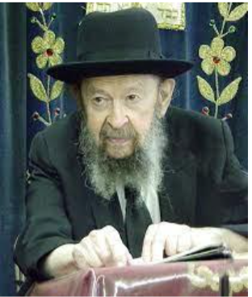

ANSWER: And the answer is, why did Hashem create bees that sting? And why did He create snakes that have venom?
The answer is everything in the world is purposeful. כל מה שברא הקדוש ברוך הוא בעולמו לא בראו אלא לכבודו – Everything declares the glory of Hashem (Avos 6:11).
Now if we didn’t have subnormal children, then the people who have normal children would be entirely unaware of their happiness.
Now, that may seem to us a cruel thing to bring a crippled child into the world in order to make mankind aware of normal children. But the fact is it’s even a greater pity that such an expenditure is made and despite that people don’t learn.
Everybody who has a normal child or if you yourself are normal, you should never stop being happy. Never stop thinking, “Why wasn’t I born a Mongolian?”
Did you ever see a man pushing his big son, a 16-year-old boy in a wheelchair? You see right away he has a queer face and the boy is sitting like this. And the father is pushing him around for years and years and he’ll continue like that for the rest of his life. And that’s nachas from a child?
Suppose that father could take his son and make him look like you and behave like you. How would the father dance with simchah! He would dance more than you dance on Simchas Torah. He would dance all day long. And so would the son.
And therefore, one lesson is for the people who are preserved from such blemishes to learn and to rejoice. You have normal children? Be happy to no end!
Now, the question is what about these children themselves? Although these children serve an important function, we want them to be compensated for their services. Actually they do a lot of services for us because these children, these crippled or retarded people are the recipients of the kindliness of others. They give people opportunities to do mitzvos. If there were no sick people, so how could you do all these good deeds for which people are zocheh to Olam Haba and also to Olam Hazeh?
But in addition to all this, the crippled child receives a reward. Hakadosh Baruch Hu compensates them in the World to Come. They do not lose out.
And if you’ll say, “Is it fair they should lose out in this world? After all, this world they’re not getting.”
And the answer is, this world is nothing but a deception. It’s only a superficial scenario. It comes to an end before you know that it’s over. It’s all over! Nobody is satisfied with the length of days. It’s too quick for him. And then there comes senility and illness and death. Everybody must leave the world.
And so, the success of a man depends not on this life but on what happens in the Afterlife. And in the Afterlife, the deprived children will be fully rewarded for their work that they served in this world, and they’re not going to lose anything!
On the contrary, he could have lost a great deal because actually it’s dangerous to be normal in this world! If a person is normal and doesn’t utilize the opportunities, he’s held accountable. But these poor children didn’t have any choice and Hakadosh Baruch Hu gives them a full payment for a full lifetime of service to Him.
And therefore, the justice of Hashem is exonerated and vindicated by Olam Haba.
September 1983

Reprinted from a recent email of Torah Avigdor based on a September 1983 question-and-answer session from a classic Thursday night hashkafah lecture of Rav Avigdor Miller, zt”l.

Thoughts that Count for Parshas Ha’azinu & Yom Kippur

Of the Rock that bore you were you unmindful; and you forgot the G-d Who bore you (Deut. 32:10)
When G-d created man He gave him the gift of being "unmindful" - the ability to forget and allow time to heal the wounds which would befall him in this world. But, G-d claims, what did you do with this gift? You misused it, and forgot about Me! (Rabbi Menachem Mendel of Kotzk)

...He, and Hoshea the son of Nun" (Deut. 32:44)
Why was Joshua referred to here by his original name, Hoshea? To inform us that although he was being given a position of greatness as the successor of Moses, he did not become egotistical or overbearing. He remained the same as always. (Rashi)
The King who forgives and pardons our transgressions (from the Yom Kippur prayers)
How can we be so certain when saying this blessing that G-d pardons and forgives our transgressions? The Rozhiner Rebbe explained: "When I was a little child, we once had apples in our house. I desperately wanted an apple but my father didn't want to give me one. What did I do? I made the blessing over the apple in a loud voice and motioned to my father to quickly give me an apple so I wouldn't have uttered a blessing in vain. He didn't have a choice but to give me the apple. It is the same with us. When we call G-d 'the King who forgives and pardons...' G-d doesn't have a "choice" as it were, and he must forgive us. Otherwise, we would be saying G-d's name in vain.
(He) forgives our sins, year after year (from the Yom Kippur prayers)
A person, if wronged, will forgive after the guilty party apologizes. But he will find it more difficult to forgive a second time if the same thing occurs again. How much more if it happens a third or a fourth time. G-d's attribute of mercy, however, has no limit or boundary, as it states, "For his mercy endures forever." Whether the apology comes the first time or the thousandth time, it is all the same. (Rabbi Shneur Zalman, Igeret Hateshuva)

Reprinted from the Parshat 5763/2003 (Issue #789) email of L’Chaim, a publication of the Lubavitch Youth Organization in Brooklyn, NY.
Surviving 9/11: Four Jewish New Yorkers Remember That Day
By Yehudis Litvak

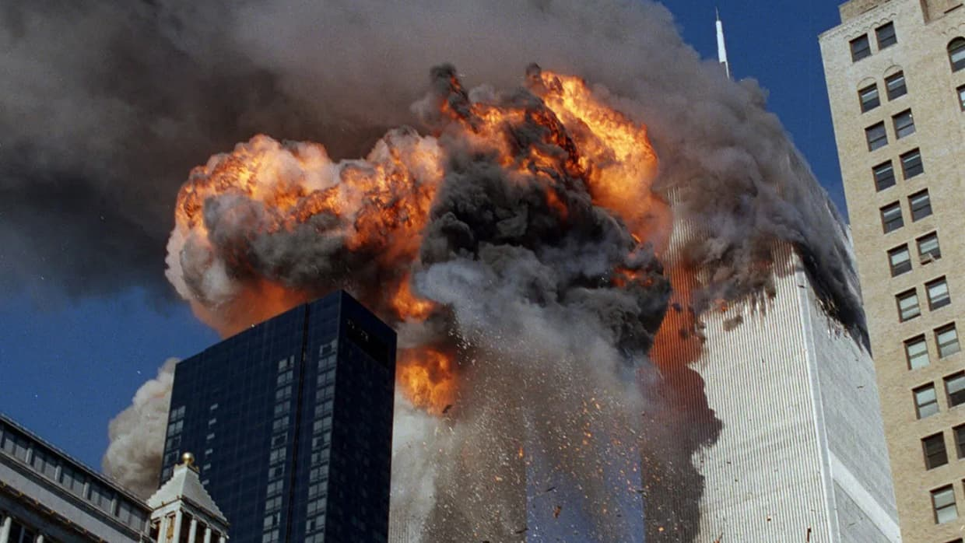
Twenty-five years later, four survivors relive the day terror came to New York City.

The Twin Towers of the World Trade Center symbolized the success of the Western values that Americans held dear: freedom, equal business opportunities, and the pursuit of happiness. Not surprisingly, they became a target for Islamic terrorists out to destroy Western civilization.
The first terror attack on the World Trade Center took place on February 26, 1993. Simon Swidler, who had worked for over two decades for the New York Stock Exchange, was at work on the 30th floor of the South Tower. “I felt a rumble, the building shaking,” he recalls. “Then the electricity went out. You could not take the elevator. So, thousands of people were stumbling down the emergency staircase in the dark.”
Fortunately, Simon had a flashlight, because “somehow I passed the store that week, it looked like a good price, I bought it. It was very useful!”
Simon lit the way for himself and for the people around him. Later, he found out that six people were killed and over a thousand injured when a rental truck filled with over a thousand pounds of explosives blew up in the parking lot under the North Tower.
Within weeks, the FBI captured several Islamic terrorists behind the attack. The mastermind of the operation, Ramzi Yousef, was captured two years later. In an interrogation, he revealed that his plan had been to topple the North Tower onto the South Tower, thus destroying both.
Yousef’s plan failed and he is currently serving a life sentence. However, his uncle, Khalid Sheikh Mohammed, determined that the next attempt would succeed. He was the mastermind behind the 9/11 attack on the Twin Towers.

The Attack
The morning of Tuesday, September 11, 2001, was “a beautiful day,” recalls Batshevah Reznik, who lived in Brooklyn at the time. “Perfect weather, not a cloud in the sky.”
The streets of New York were full of people hurrying to work. Kira Sirote, who lived in Israel and was in New York on her biannual business trip, had taken the subway from her parents’ home on Long Island to her office at 100 Wall St, a few minutes’ walk from the Twin Towers.
Kira was supposed to fly back to Israel the following day. She decided “to come into the city a little early and go shopping for a bit, buy gifts for my husband and children.” She debated between going to the Warner Brothers store, located in the World Trade Center, and the Century 21 store across the street. Fortunately for her, she chose Century 21.
She recalls, “I was shopping, and all of a sudden, I heard thunder, which was strange on a clear day. I looked out the window and saw a fireball in the World Trade Center. And then I saw stuff falling from the sky.” Coming from Israel in the midst of the Second Intifada, Kira’s immediate thought was that it was a terror attack.
At the time, she didn’t know that five terrorists hijacked a Boeing 767 airplane, on its way from Boston to Los Angeles, and flew it into the North Tower. It was 8:46 a.m.
Meanwhile, Simon was still trying to get to work. “I would have been at my desk normally by 8:30,” he says. “That morning, when I got to the platform to catch the 7:14 train, an announcement came over the loudspeaker saying, a branch has fallen onto the railroad tracks, the 7:14 train is canceled, take the next train. I took the next train and I was cursing my luck for coming late to work.” Little did he know that the fallen branch might have saved his life.
By the time Simon got to the World Trade Center subway station, “there was a strange sight. People were streaming away from the building.” No one knew what was going on, but a guard told Simon to go across the street.
Meanwhile in Brooklyn, Zushie Rimler, a member of the Hatzalah Volunteer Ambulance Services, received an emergency call. “Our Hatzalah unit left Brooklyn as soon as the first plane crashed,” he recalls. “While enroute the second plane crashed and at that moment, we all knew that this was no accident.”
This was the second Boeing 767, also on the way from Boston to Los Angeles, hijacked by five terrorists and flown into the South Tower at 9:03 a.m.
From the rooftop of her workplace in Brooklyn, Batshevah saw the airplane hitting the South Tower. “The explosion was indescribable,” she recalls. Batshevah realized that she could have been there. Just recently, she had applied for her dream job in that area and was very upset when she didn’t get the job. She continues, “And then all the phones went dead. My parents, who lived in Houston at the time, thought that I was gone.”
Meanwhile, Zushie’s Hatzalah ambulance followed a fire truck through the standstill traffic. “Many firemen and police officers started jumping into our ambulance to catch a ride to the scene, until we were as packed as a rush hour subway car,” he says.
When the Hatzalah team realized they would be unable to reach the designated staging area, “we stopped our ambulance two blocks north and walked our stretcher and equipment down to the scene,” recalls Zushie. “When we arrived, both buildings were burning. As we were walking towards the towers it appeared that there was debris flying from the windows. When we got closer, we could see that this wasn’t debris, there was a steady stream of people coming out of those windows. I don't know if they were jumping or falling, all I know is that there were many, many people. The scene was horrific. The details are too graphic to repeat.”
Simon describes what he saw from across the street: “Aside from the smoky conditions on the upper floors, I saw fluttery things falling from [the North Tower]. People around me said, those are people jumping. Then the second plane hit my building!”
He continues, “The debris from that impact was falling onto the street, including where I was standing. The whole crowd took off. I was knocked down. I think a lot of people were knocked down, because it was a panic and a mob reaction. I escaped by running as fast as I could.”
Meanwhile, at 9:37 a.m. a third hijacked plane, Boeing 757, enroute from Washington, D.C. to Los Angeles, hit the Pentagon, the headquarters of the U.S. Department of Defense. 59 passengers and crew and 125 people inside the building were killed on impact.
The fourth plane, also Boeing 757, enroute from Newark to San Francisco, was hijacked around 9:30 a.m. By then, the passengers had already heard about the previously hijacked planes used as weapons, and they decided to fight back. It is unknown what the terrorists’ intended destination was, but after a group of passengers attempted to take control of the cockpit, the hijackers crashed the plane into a field in Pennsylvania. The 40 passengers and crew were killed. No one else was at the impact site.

When the Towers Came Crashing Down
The Hatzalah members, meanwhile, were trying to figure out what they could do to help. Zushie recalls, “Our fifteen Jewish volunteers were grouped with another ten/fifteen emergency workers, and the Fire Department assigned a lieutenant over our group. We were getting ready to enter the South tower, when the lieutenant received word over his radio that two FDNY personnel had died as a result of the falling victims. Being that we didn’t have proper helmets the decision was made that we would remain positioned about fifty feet away from the tower with the plan being that the few hundred firemen who had just entered the buildings would bring the patients out to us for treatment.”
A supervisor from the Fire Department was uncomfortable with the Hatzalah group joining the firefighters. She sent them across the street. Zushie says, “We started walking with our equipment, when suddenly we heard an indescribable noise, like the roar of a jet engine. Everyone started running away from the noise, afraid that a third plane was coming. Some guys managed to run all the way across the street to the Financial Center, but I never made it that far. My back was to the towers, and I had no idea what was happening. It started getting darker and darker, things were falling and I was getting hit again and again.”
The South Tower had collapsed at about 10 a.m. Desperate for some kind of cover, Zushie crawled under a car. “It was so dark, and thick dust was filling the air fast,” he recalls. “We couldn't see anything, and it felt like someone had taken my face and buried it in a sandbox, every breath filled my lungs with sand. I was sure I was going to die. I remember screaming Shema Yisrael, praying for my family, and thinking, I came here to help people, but now who will take care of my family?"
He continues, “Once things stopped coming down, there was this eerie silence. There was no screaming, no sirens, just total quiet. It was extremely hard to breathe. Every attempted breath filled your lungs more and more with sand. I tried using my shirt to filter the air, but it was also just covered and full with that toxic dust.”
Zushie thought that he was the sole survivor when he heard “a sound of someone else coughing and struggling to breathe.” Stumbling toward the sound, he was overjoyed to find his own brother Yitzchak, also a Hatzalah volunteer.
“We were coughing and gagging,” Zushie says. “We started walking in the direction we had come from, barely able to see, just trying to feel our way. We walked back to where we had been stationed originally, before the supervisor from the fire department had sent us away. The chunks of steel and concrete that we found there were insurmountable. We could not even climb over them to get out. Had we been standing there, we would have likely been crushed.”
“As time went on, the dust slowly began to settle, turning the air from black to gray,” recalls Zushie. “We saw a light, started walking towards it, and realized that it was coming from the front of a fire truck. Once we approached the truck, we saw that all the firemen inside had been crushed.”
They kept walking, rescuing a firefighter along the way. Another firefighter was wounded and unable to come with them. They had no choice but to leave him behind, something that “haunts me continuously,” says Zushie.
As they got farther away from the World Trade Center, “it was becoming lighter. We walked until we reached the Hudson River. We found a bench and put the fireman down.” It was then that Zushie realized he was bleeding from his head. Surrounded by dead bodies, Zushie didn’t think his injury was top priority.
Rescuers began evacuating people from the riverbank by boat. “It was only then that we were told that the South Tower had collapsed,” recalls Zushie. “We started helping people over the seawall and onto the boats, including the fireman that had come with us. Suddenly we heard that same loud sound again, but this time we knew that it was another collapse.” The North Tower collapsed at about 10:30 a.m.
A police officer ordered the brothers onto a boat. They were taken to Liberty State Park in New Jersey. Zushie says, “When we got off the boat, I was feeling dizzy. After a short while, I started feeling somewhat better, and kept thinking of all the people who needed help, and that we can’t just leave them there to die.”
When Zushie returned to Manhattan, “everything was covered with white soot,” he recalls. He couldn’t even see the bodies anymore. He also couldn’t treat the wounded because his equipment had been destroyed. Instead, he helped with evacuating “anyone able to walk” from the area.
When Zushie arrived at the triage center at Chelsea Piers, his fellow Hatzalah volunteers were concerned about him. He says, “My lungs were hurting, and I looked like I was on the verge of collapsing. They wanted to take me to the hospital, but I assumed the hospitals would be packed, so I declined.” Instead, he was taken to his doctor's office together with several other volunteers. Miraculously, all the Hatzalah members survived 9/11.
Simon, meanwhile, kept running. He recalls, “On the way, I saw dropped shoes, cell phones, debris of all kinds, but there was nobody standing still, everybody was running. I reached Broadway and forced my way into a store that was closing because they weren't going to stick around to find out what was going on. I said, I have to call my wife, and you have to let me use your phone. This was at a time when cell phones were still pretty new, and I didn't have one.”
He managed to reach his wife, “and all I was able to say is, I don't know what's going on, the world is going crazy, but I am okay.” Simon reached the main building of the Stock Exchange, on Wall St, and went inside for shelter. When the towers collapsed, “You could hear the rumble and feel the earthquake underneath where we stood. They call it pancaking: the buildings collapsed vertically, not like a tree falling. And it was the shock of a lifetime to see those buildings come down.”
Meanwhile, at Kira’s office, the management decided to send everyone home. Kira didn’t think it was a good idea. “If people are panicking in the subway, it’s much more dangerous than anything we could do in the office,” she says. But everyone else was worried that their building was also going to be attacked.
Both Simon and Kira had to walk over the Brooklyn Bridge to catch a train home. “That was quite the experience,” recalls Kira. “We were walking on burnt paper. The ash ruined my shoes. There were lots of people walking there. I remember somebody being pushed in a wheelchair. When we got to the Brooklyn side, people were standing there giving out water.”

The Aftermath
Rescue workers continued searching the area, hoping to find pockets of air where survivors might be trapped. Thousands of people participated in the rescue effort. By the afternoon of September 12th, 18 people were found alive. From then on, the rescue operation slowly shifted to recovery. Human remains, as well as personal belongings found in the rubble, were analyzed for DNA. While some victims were identified and declared dead, most were not identified for years. Some have still not been identified. The total death toll at the site was 2,753. Out of them, 441 were first responders who had rushed to help.
The recovery and cleanup operation continued until May 2002. For months, Lower Manhattan was covered in debris. “Silver and gray particles were floating everywhere,” recalls Simon. Though the area was deemed safe and people were allowed to return to work two weeks later, “the surfaces were still coated with dust,” says Simon. “A lot of people got sick from breathing the air, especially the firemen who had the duty of digging into the ashes. A lot of them got lung disease or cancer. I myself came down with cancer about 10 years later.”
Fortunately, Simon recovered. Zushie developed asthma as a consequence of his 9/11 experience and is currently managing it with medication.

The Impact
In the months following the attack, the atmosphere had changed.
Kira says, “The following time that I went back to New York, people were making eye contact in the subways, which they didn't used to do. They were much more together, it was much more like, we got through this, we can do this, we can do anything, we're there for each other.”
For many Americans, 9/11 was a wakeup call. For Jewish Americans, especially those who have spent time in Israel, it brought the realization that Islamic terror had spread past Israel and into the Western world.
Simon recalls that at that point, three of his children were living in Israel, and his wife had been eager to make aliyah and join them there. “I was dragging my heels,” he says. “We led a comfortable life in America. But after 9/11, I changed my mind.” When his children, living through the Second Intifada, were calling him, anxious to find out if he was okay, “this was upside-down,” says Simon. “This means that there is no place that's safe, that the danger is everywhere. And so, what am I doing here? We made our 5-year plan, and we made aliyah in 2007.” They currently live in Jerusalem.
Many survivors feel that G-d had spared their lives when, for whatever reason, they were late to work that day. Batshevah’s disappointment at not getting her dream job quickly turned to gratitude. “If something is not working out, do not get upset,” Batshevah says. “We don’t see the whole picture. The A-mighty has His ways. We need to trust that it’s for the best.”
The survivors feel that it is important to remember 9/11: its heroes, its victims, and the hatred of Western civilization that led to it. “New York has always been a very special city,” concludes Kira. “G-d willing, it'll survive what it's going through now, also.”

Reprinted from the current website of aish.com

